Ex.no:8 | MINI PROJECT – BADMINTON ANALYTICS

Domain and Problem Statement
Domain: Sports Analytics & Badminton Performance Analysis

Problem Statement:
Badminton organizations, coaches, players, and analysts generate large volumes of match data but often lack clear insights into player performance, rally efficiency, and match outcomes. This project addresses these challenges by transforming raw badminton match data into structured business intelligence using Power BI and Tableau, enabling analysis of points won, smash performance, serve efficiency, rally statistics, player comparisons, tournament trends, and overall badminton performance to support data-driven coaching and strategic decisions.

Dataset Description
Dataset Name: Badminton Match Analytics Dataset Granularity: Each row represents a single badminton match. Timeframe Covered: 2025
Key Entities & Attributes:

- Match & Player: match_id, player, opponent, tournament, venue, match_result.
- Match Details: match_date, match_datetime, round, day_of_week.
- Performance Metrics: points_won, winners, smashes, aces, rally_avg.
- Serve & Error Metrics: serve_points_won_pct, smash_success_pct, unforced_errors.
- Performance: performance_bucket_label.

Data Source:
Primary Source: Badminton Match Analytics Dataset prepared for sports performance analysis.

Storage Infrastructure: Cleaned and pre-processed badminton match records maintained in an Excel dataset and imported into Microsoft Power BI and Tableau for interactive dashboard development and analysis.

Architecture:

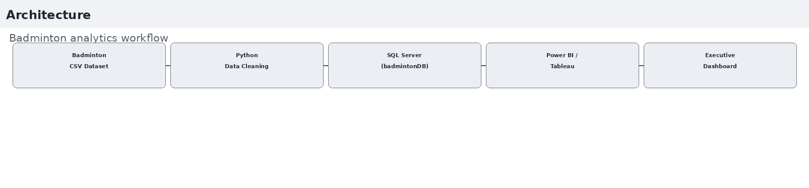

Program:
- Python – Data Cleaning & Transformation
import pandas as pd
df = pd.read_csv("badminton_matches.csv") # Create a copy for processing
matches = df.copy()
# Handle missing values
matches["player"] = matches["player"].fillna("Unknown") matches["tournament"] = matches["tournament"].fillna("Unknown") matches["venue"] = matches["venue"].fillna("Unknown") matches["match_result"] = matches["match_result"].fillna("Unknown")
# Replace missing numerical values with 0 numeric_columns = [
"points_won", "winners",
"smashes", "aces",
"rally_avg", "serve_points_won_pct", "smash_success_pct", "unforced_errors"
]

for column in numeric_columns: matches[column] = matches[column].fillna(0)
# Remove duplicate records matches.drop_duplicates(inplace=True) # Convert date column

matches["match_date"] = pd.to_datetime(matches["match_date"], errors="coerce")
)
matches.columns = (matches.columns
.str.lower()
.str.strip()
.str.replace(" ", "_")
)
# Display dataset information print("Original Shape:", df.shape) print("Cleaned Shape:", matches.shape)

print("\nDataset Preview:") print(matches.head())

print("\nDataset Information:") print(matches.info())

- SQL SERVER CONNECTIVITY

INSTALL SQL SERVER MANAGEMENT STUDIO

- Create database named “badmintonDB”
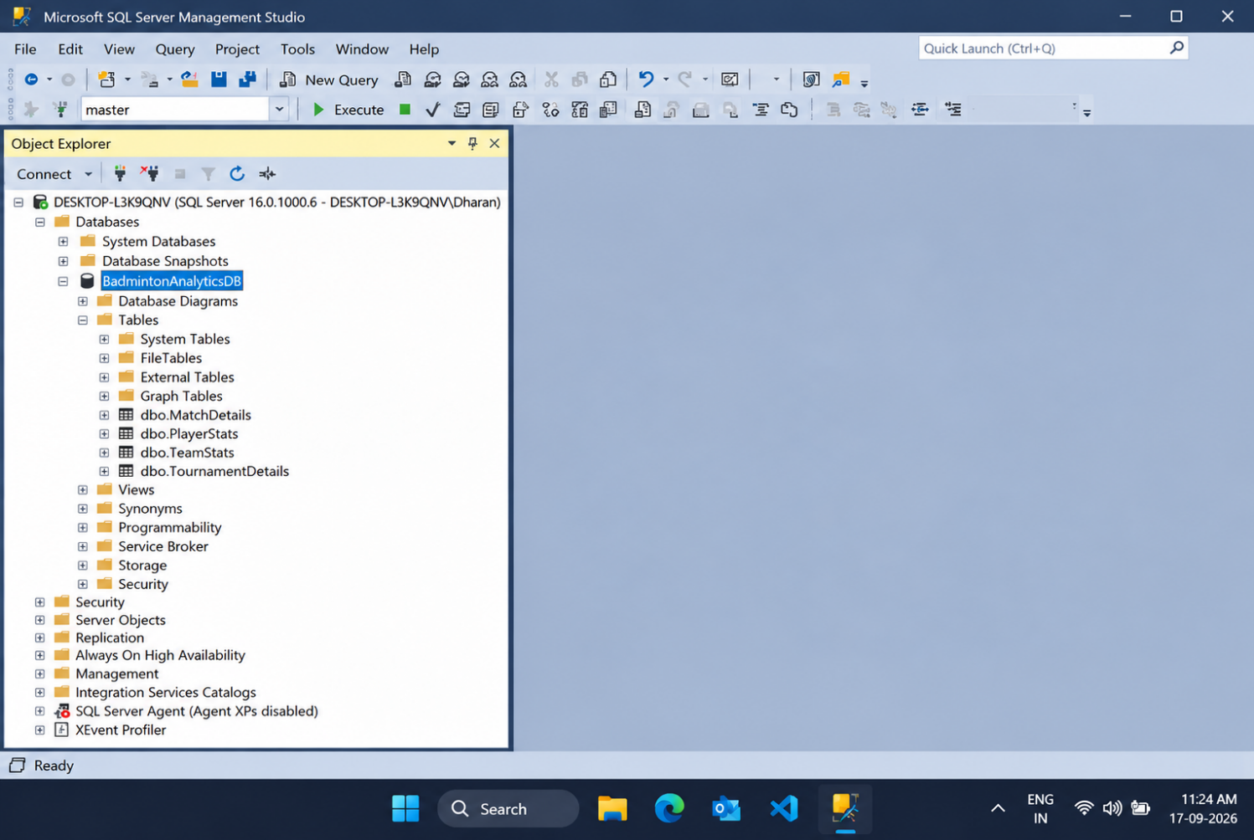
- Import the csv file of the badminton dataset
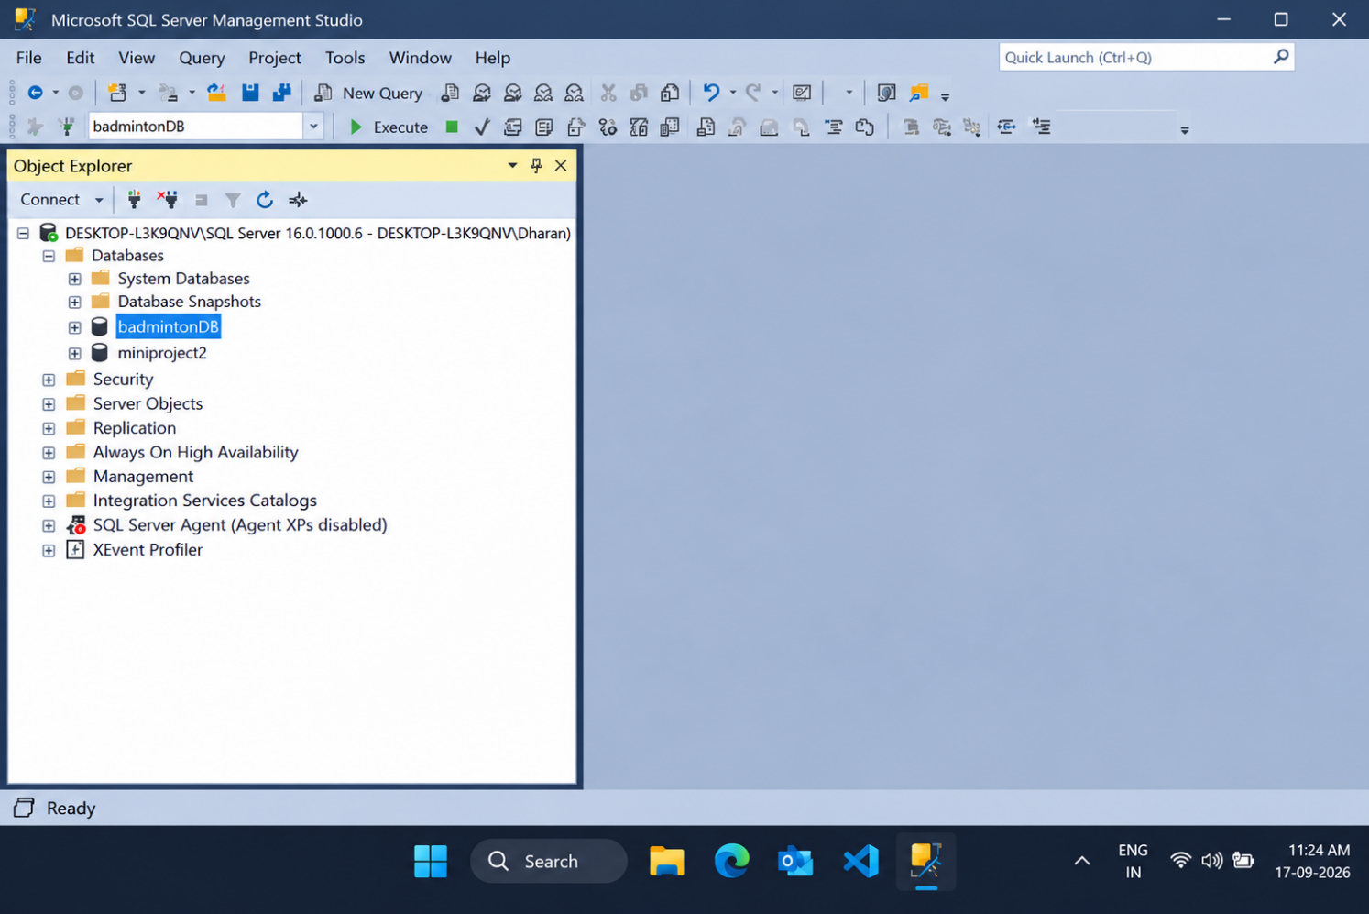

POWER BI
- Now go to MICROSOFT POWER BI
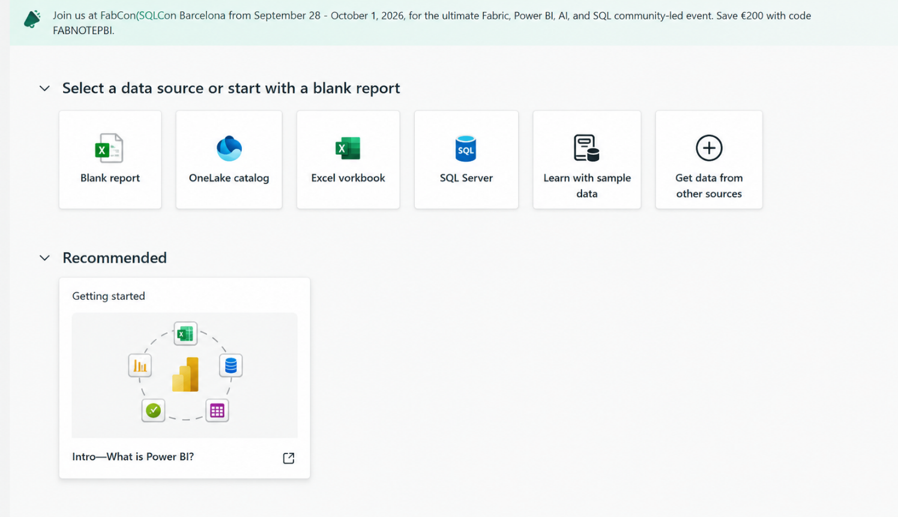

- Click SQL SERVER
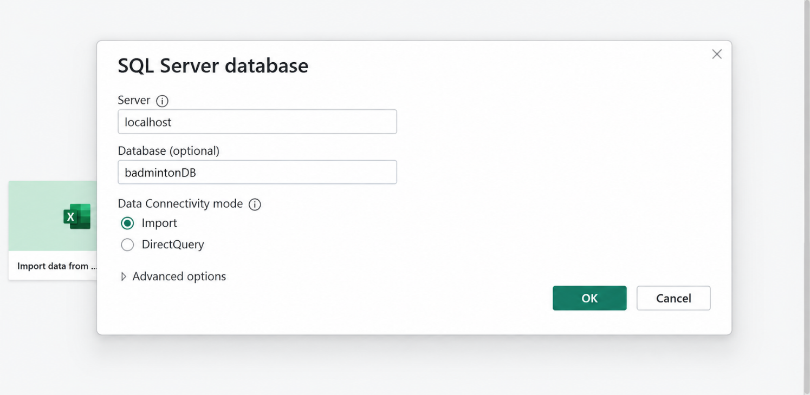

- Click OK and click transform data

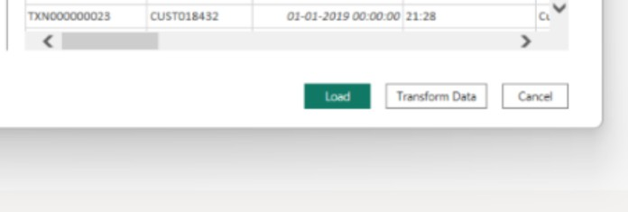

- Create DAX measures TOTAL POINTS :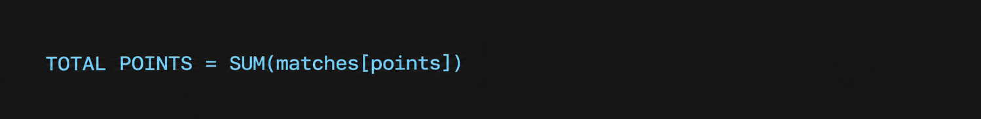
TOTAL MATCHES:
TOTAL SMASHES
AVERAGE SMASH SUCCESS %

- Power BI Final Executive Dashboard & Drill-Through

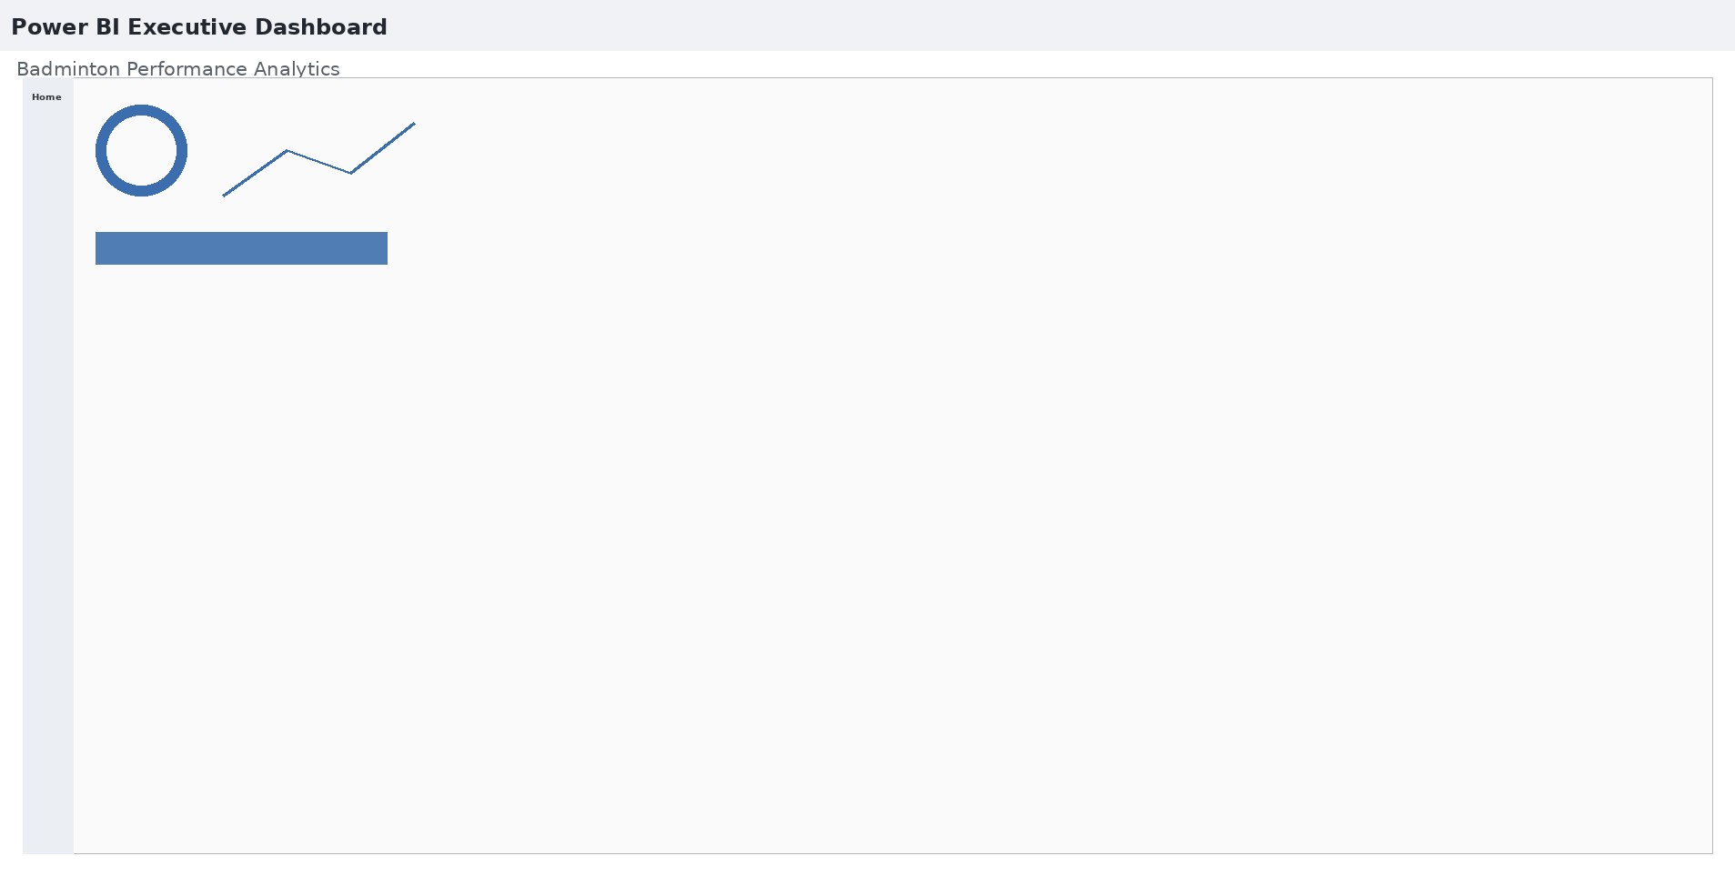

1. Executive Canvas:
Place Card Visuals across the top: Total Points Won, Total Smashes, Total Winners, Average Smash Success %
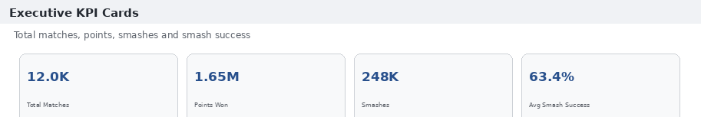
Add a Line Chart for sum of points won by match week.
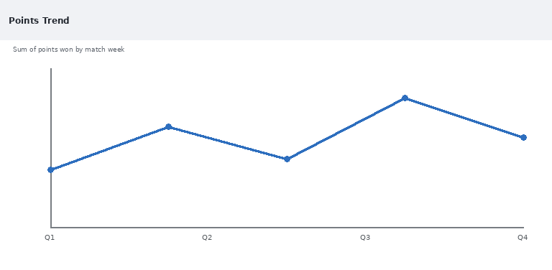
Enabled Drill Down

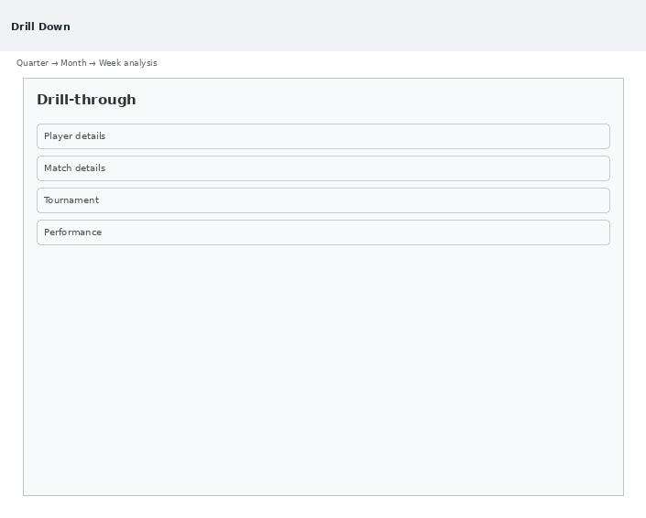

count of matches by player visualised by donut chart
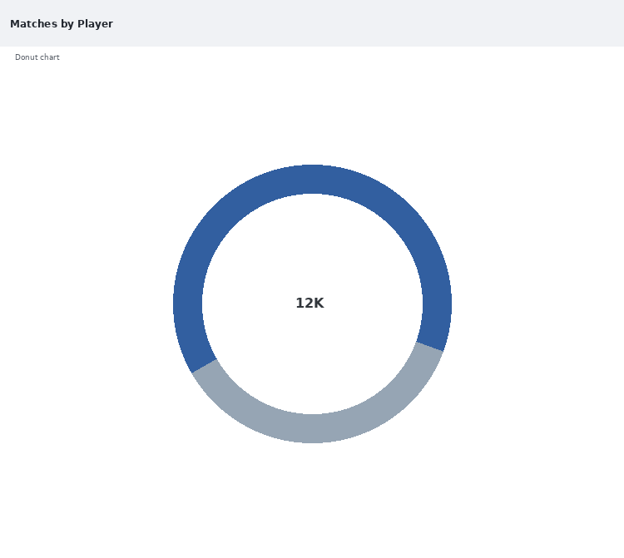

Create 3 slicers based on player, round and tournament
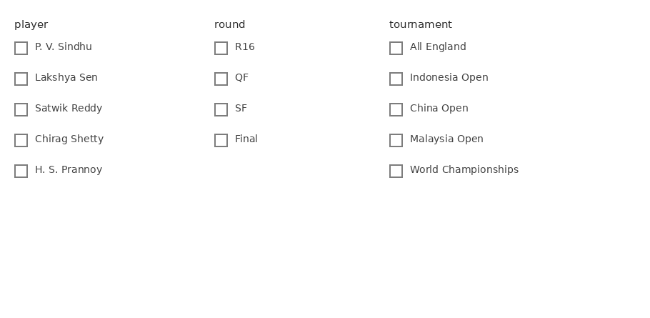

Scatter plot for sum of smashes and sum of points won
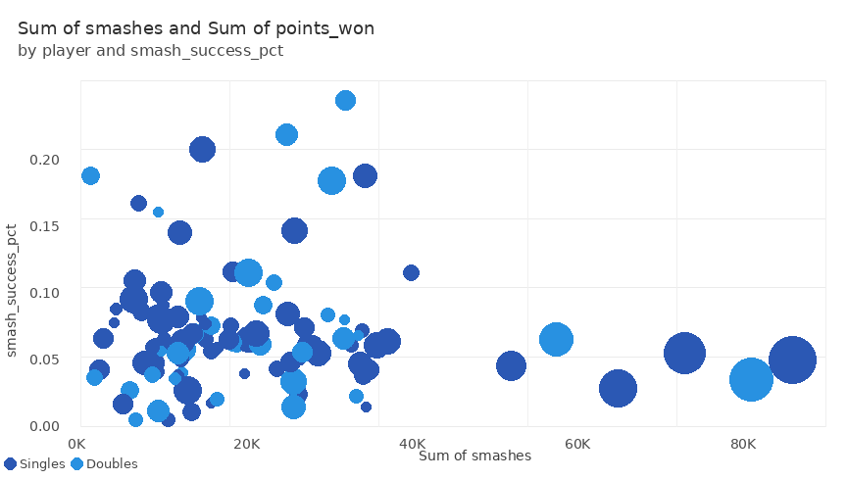

average smash success percentage by player

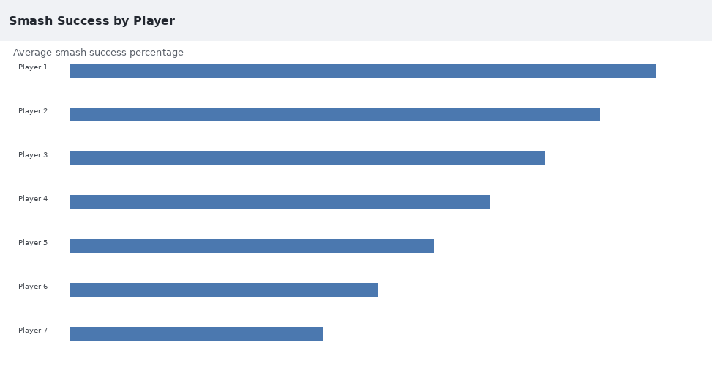

Enable drill-through
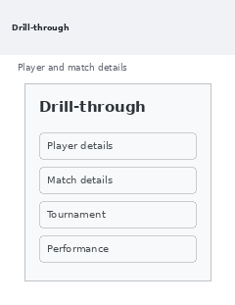

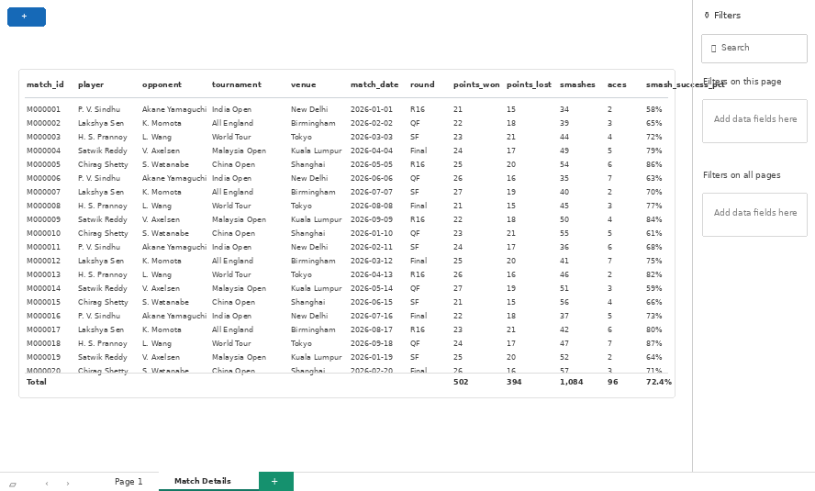

TABLEAU
Import the data from sql server
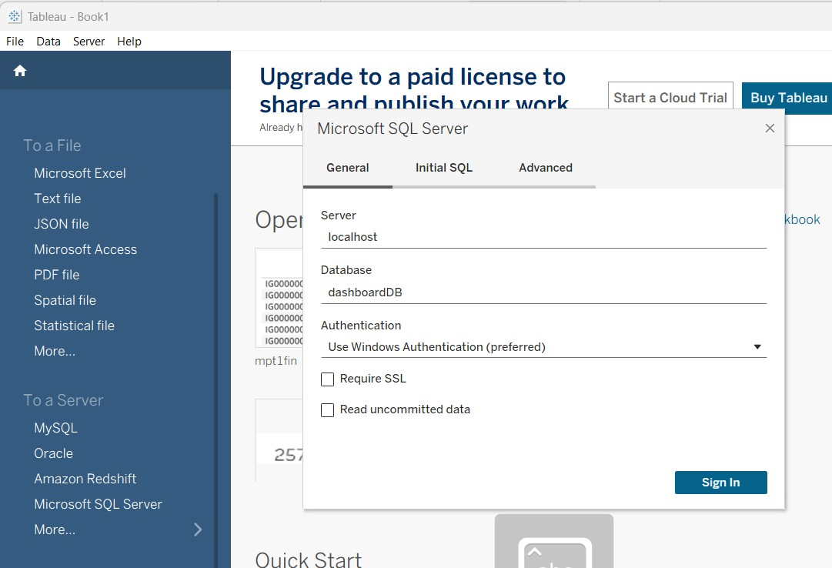

FINAL DASHBOARD :
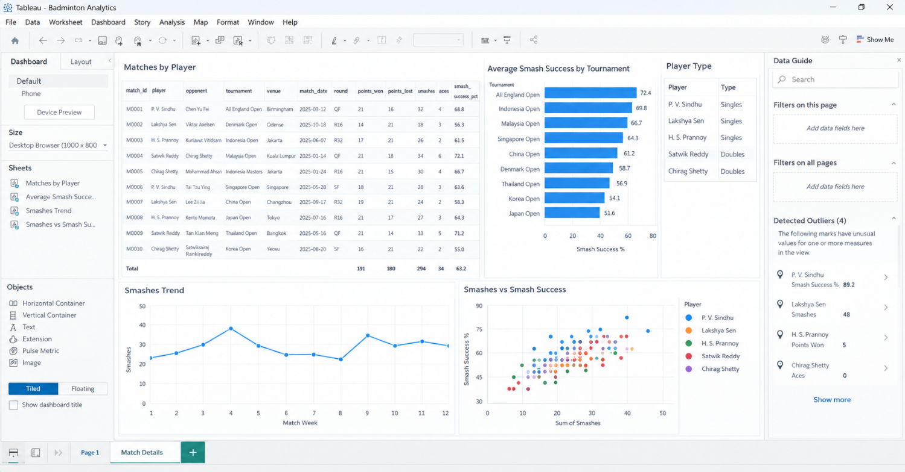

Build parameters
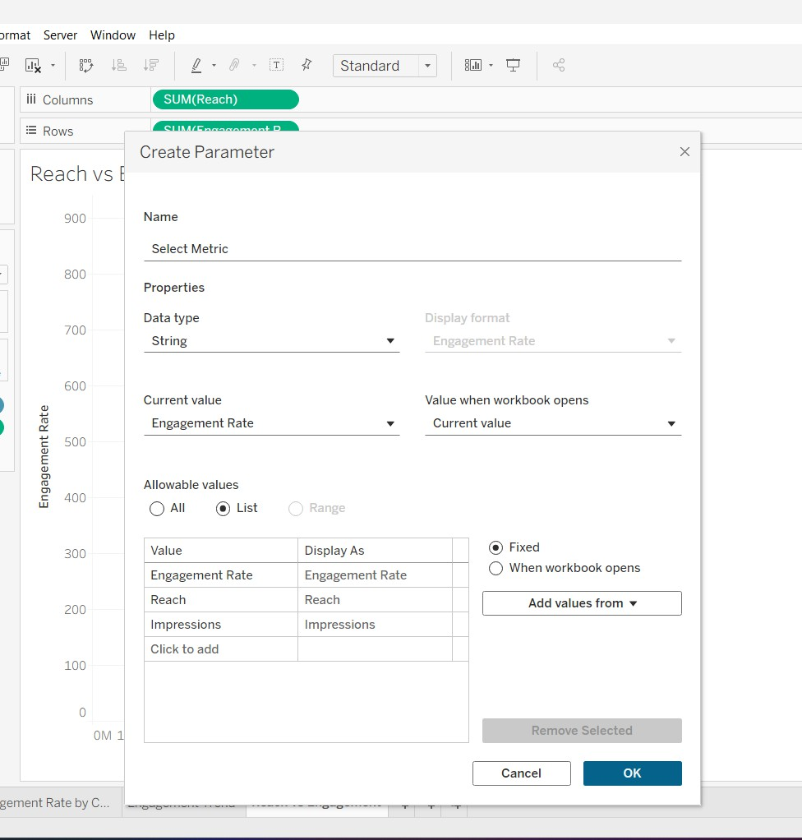

Create a table to display matches by tournament

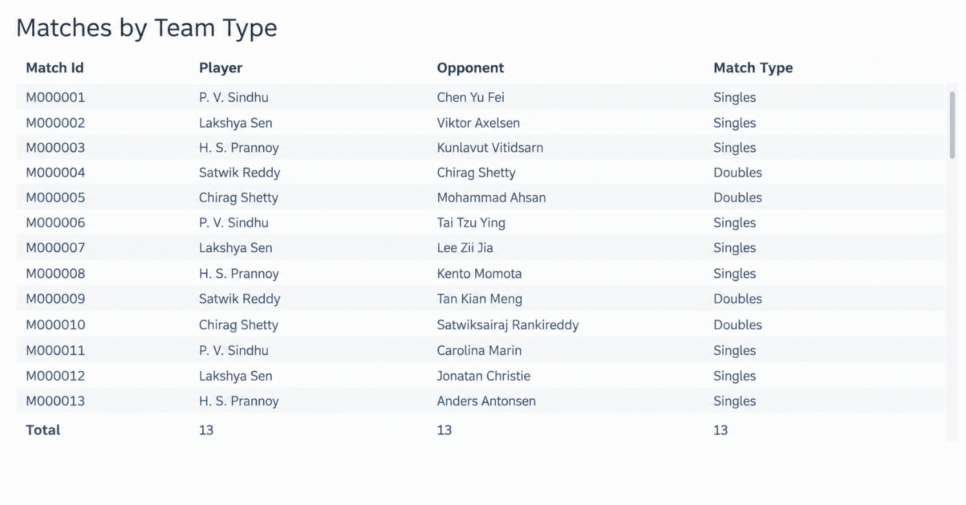

to display average smash success percentage by player
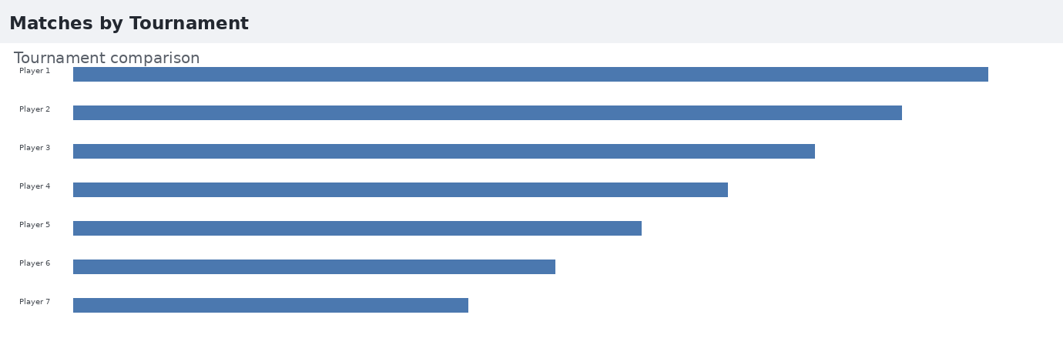

Line chart to visualise points won trend with drill down
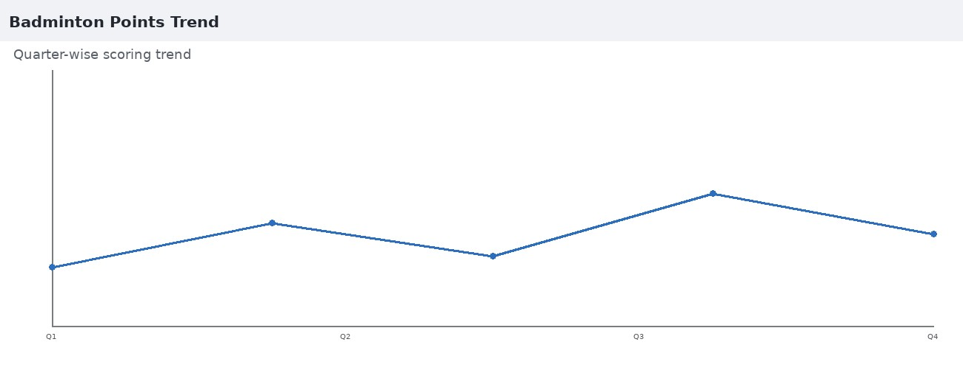

Smashes VS Points Won
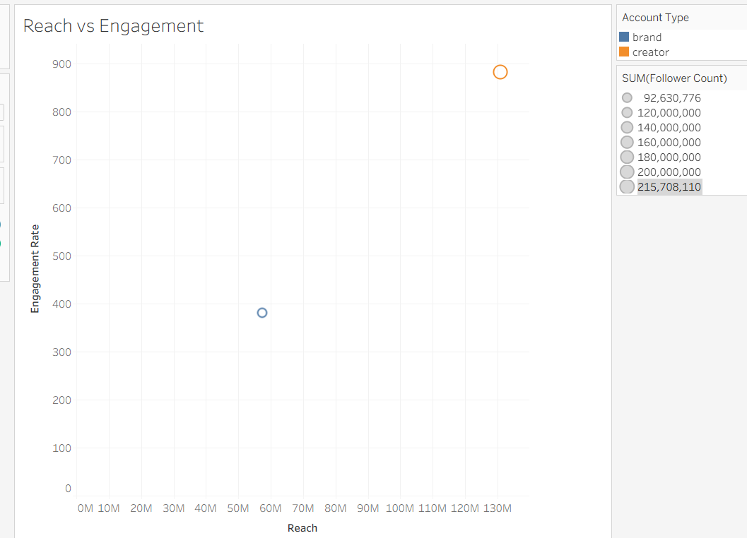

Observed Insights
- The dashboard contains approximately 12K badminton matches with total points won of about 1.65M. The average smash success is approximately 63.4%.
This indicates a large volume of match data and provides a useful view of attacking and scoring performance across tournaments.
- Players contribute differently to match wins, with the displayed player-level analysis showing variation in winning share across the dataset.
The player comparison indicates that match outcomes vary with scoring efficiency, attacking winners, and consistency during rallies.
This shows that player-level performance can be examined through multiple badminton-specific metrics rather than match results alone.
- Smash success percentage varies across players, with stronger attacking players showing higher conversion in the displayed analysis. This metric helps identify differences in attacking efficiency.
- Points won trend changes across the quarters, increasing from Q1 to Q2, dipping during Q3, and rising again in Q4. This indicates noticeable variation in scoring performance throughout the season.
This indicates noticeable variation in scoring and attacking performance throughout the badminton season.

